**XFlow** MARKETS

PULSE

D A I L Y - R E P O R T

31-07-2024

**GBP/USD** **CMP** – 1.2843

GBP/USD is trading at 1.2843, 0.07% up since previous day close. In the Asian hours of Wednesday, the GBP/USD pair retraces some of its recent losses, trading at 1.2840. Despite the Federal Reserve and Bank of England's monetary policy pronouncements on Wednesday, investors do not appear to be willing to commit to a direction in the pair. RSI reaches 48, signaling a consolidating or reversal period, according to daily chart analysis. At 1.2818 and 1.2863, respectively, there is the closest support and resistance.

**Resistance– 1.2863-1.2887 Pivot- 1.2840 Support-1.2818-1.2783 Expected Trend- Bearish**

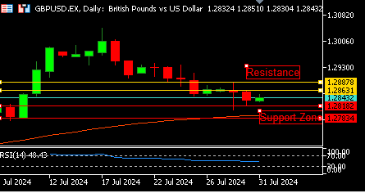

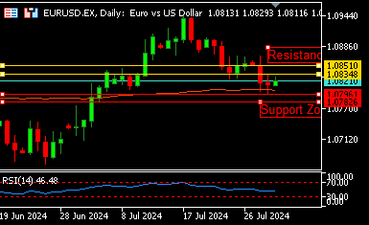

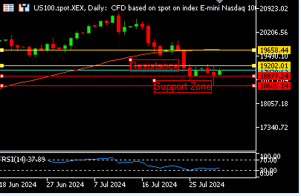

**EUR/USD**  **CMP** – 1.0824

EUR/USD is trading at 1.0824, 0.10% up since previous day close. Ahead of Eurozone inflation statistics, EUR/USD continues to rise beyond 1.0800. Both the Fed and the ECB are anticipated to reduce interest rates soon. While the Eurozone's recovery is gaining less impetus, perhaps medium-term weakening the Euro even further. According to daily chart analysis, a bearish spinning top appears in the candle from the previous day, indicating a trend reversal. Resistance is at 1.0834, and the nearest support is at 1.0796.

**Resistance-1.0834-1.0851 Pivot- 1.0823**

**Support- 1.0796-1.0782 Expected Trend-** **Bearish**

**US 100**  **CMP** – 19052

US 100 is trading at 19052, 1.75% up since previous day close. As megacaps and chips decline ahead of Big Tech results, nasdaq plummets. Expectations that the Federal Reserve will announce a reduction in September in its policy decision on Wednesday have been strengthened by the ongoing improvement in inflation and the slowing labor market. The RSI reaches 39, according to daily chart analysis, which indicates that purchasing may now begin. The nearest resistance is 19202, while the closest support is 18877.

**Resistance: 19202-19658 Pivot- 19086**

**Support: 18877-18605 Expected Trend- Bullish**

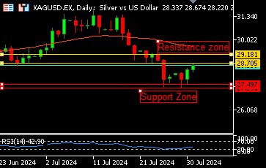

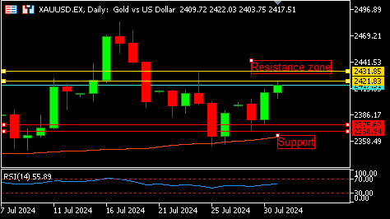

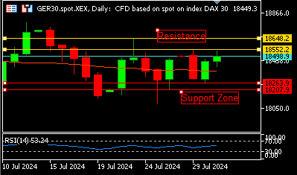

**GER30** **CMP** – 18492

GER30 is trading at 18492, 0.29% up since previous day close. Heavyweight ASML led overall gains on news that the Dutch chip equipment manufacturer was exempt from a new U.S. ban on foreign chip equipment exports. European equities rose about 1% on Wednesday, propelled by a plethora of business updates. The daily chart analysis shows that the market opened with a gap today and moved over the 50-day moving average, pointing to a bullish trend. 18552 is the closest resistance, and 18263 is the closest support.

**Resistance – 18552-18648 Pivot- 18392**

**Support – 18263-18207 Expected Trend – Bullish**

**GOLD** **CMP** – 2418

XAU/USD is trading at 2418, 0.30% up since previous day close. In Wednesday's European session, Gold performs admirably. Following reports that investors saw precious metal investments as a safe haven amid geopolitical tensions, fears of a full-scale conflict between Israel and Iran intensified. As the result of Fed policy remains uncertain. The market rises over the 50-day moving average, pointing to a positive trend, according to daily chart analysis. Support is at 2375, while the nearest resistance is at 2421.

**Resistance –2421-2431 Pivot-2399**

**Support –2375-2368 Expected Trend- Bullish**

**SILVER**  **CMP** – 28.58

SILVER is trading at 28.58, 0.68 up since previous day close. During the Asian session on Wednesday, silver rises for the second day in a row and reaches a multiday high. Silver is frequently utilized in the automotive, solar panel, Jewelry, and electronics industries for industrial applications. Daily chart analysis shows that the RSI reaches 48. A gap up opening that was observed today suggests a bullish trend. Resistance is at 28.70, while the nearest support is at 27.49.

**Resistance – 28.70-29.18 Pivot – 28.14**

**Support –27.49-27.29 Expected Trend– Bullish**

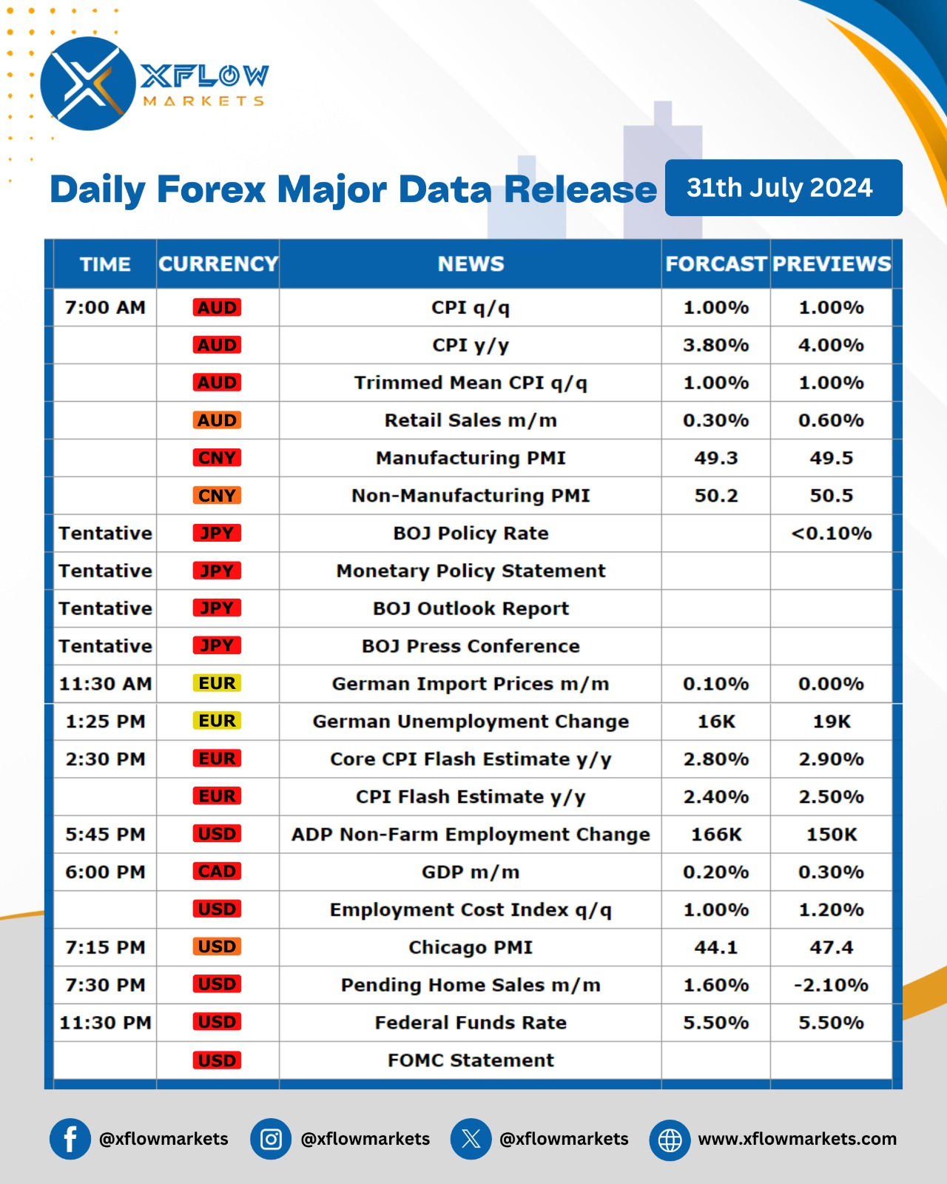

Contact us for any questions: Email:

[**support@xflowmarkets.com**](mailto:support@xflowmarkets.com)

|  |  |  |
| --- | --- | --- |
| **Follow us on FB:** | **Everyday market analysis:** | **Follow us on Twitter:** |
|  |  |  |

**Essential links:**

**Trading systems presentation - Learn and develop with us. XFlow Markets will provide you with all the help you need**

**- free seminars, webinars and learning materials.**

**Global Market Analysis - Use analysis of our professionals and be up to date.**

**DISCLAIMER:**

The content of this page has been prepared with care and diligence and with the knowledge of the author and are prepared for informative purpose only. The content of this page does not constitute investment advice. XFlow Markets does not take responsibility for investment decisions and for losses made under the influence of the information published on this website. The Client should always base his investment decisions on his own judgment. You should understand that these instruments are highly related with huge risk, and incase look for an independent advice if you have any doubts.

