**XFlow** MARKETS

PULSE

D A I L Y - R E P O R T

30-07-2024

**USD/JPY** **CMP** – 155.06

USD/JPY is trading at 155.06, 0.37% up since previous day close. In the Asian session on Tuesday, the USD/JPY has gained momentum to reach 154.00. As the US Dollar benefits from the risk-off sentiment, the pair is back on the bids. Investor attention will be closely focused on the forecast for interest rates, which is predicted to stay dovish. A bullish hammer forms in the candle from the previous day, suggesting that the market may reverse course and rise higher. Nearest resistance is at 154.74 and nearest support is at 153.53.

**Resistance– 154.74-156.03 Pivot- 153.98 Support-153.53-152.97 Expected Trend- Bullish**

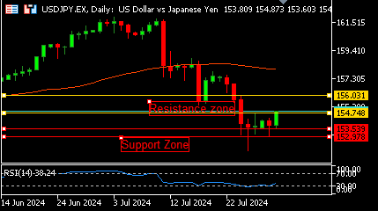

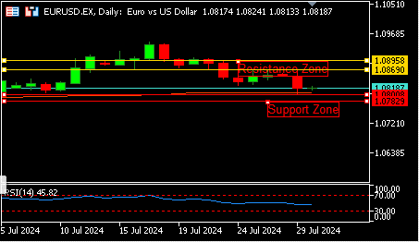

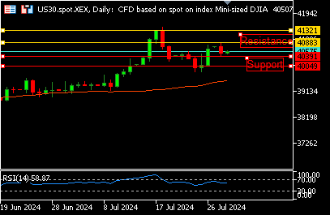

**EUR/USD**  **CMP** – 1.0823

EUR/USD is trading at 1.0823, 0.01% up since previous day close. During Tuesday's European trade, the EUR/USD pair consolidates in a range above 1.0800. The Euro is awaiting superior German and Eurozone data. Vice President recent remarks have also hinted at an interest rate drop by the ECB in September. Daily chart analysis shows that the RSI reaches 48. The four-hour figure shows that the negative tilt has accelerated somewhat thus far. 1.0800 serves as support while 1.0869 is the nearest resistance.

**Resistance-1.0869-1.0895 Pivot- 1.0819**

**Support- 1.0800-1.0782 Expected Trend-** **Neutral**

**US30**  **CMP** – 40645

US 30 is trading at 40645, 0.03% down since previous day close. Tuesday saw widespread selling cause Australian shares to fall more than 1%; banks and commodities led the losses. Later this week, there will be widely anticipated surveys on US and worldwide manufacturing, the July jobs report, and the GDP and inflation figures for the euro zone. A gap up opening signifies a bullish trend, as the RSI touches 59. The nearest support is 40391, and the closest resistance is 40883.

**Resistance: 40883-41321 Pivot- 40494**

**Support: 40391-40049 Expected Trend- Bullish**

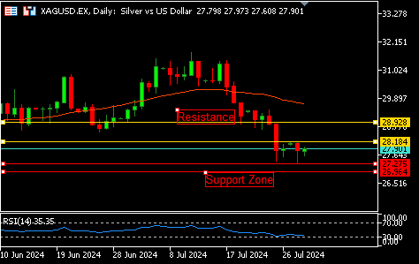

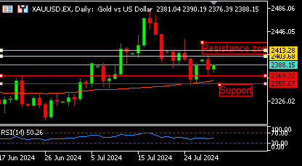

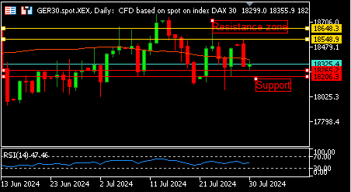

**GER30** **CMP** – 18378

GER30 is trading at 18378, 0.18% up since previous day close. Tuesday's opening of European equities was positive due to advances in oil and technology sectors, but investors refrained from making large wagers in advance of the Federal Reserve meeting and the release of inflation statistics for the Eurozone. Investors are also waiting on news on inflation in the Eurozone. A gap up opening, according to daily chart analysis, denotes a positive trend. The nearest resistance is 18548, while the closest support is 18265.

**Resistance – 18548-18648 Pivot- 18354**

**Support – 18265-18206 Expected Trend – Bullish**

**GOLD** **CMP** – 2390

XAU/USD is trading at 2390, 0.19% up since previous day close. With several forthcoming high-high macro news events from the US and Europe, the price of gold is hovering around 2,400 in the early hours of Tuesday as investors take a back seat. The market is up on the 50-day moving average (50-day MA), indicating a bullish trend, according to the daily chart analysis. Today's gap up opening was further seen. 2403 and 2369 are the closest points of support and resistance, respectively.

**Resistance –2403-2413 Pivot-2384**

**Support –2369-2355 Expected Trend- Bullish**

**SILVER**  **CMP** – 27.93

SILVER is trading at 27.93, 0.26% up since previous day close. As traders exercise prudence ahead of central banks' decisions on interest rates, the price of silver consolidates. While the BOJ may hike rates by ten basis points on Wednesday, the Fed is anticipated to remain unchanged. The demand for silver is weakened by China's unimpressive GDP forecast. When the RSI reaches 35, an oversold zone is indicated. The market may be consolidating or declining today. 28.18 represents resistance, and 27.27 is the closest support.

**Resistance – 28.18-28.92 Pivot – 27.77**

**Support –27.27-26.96 Expected Trend– Neutral**

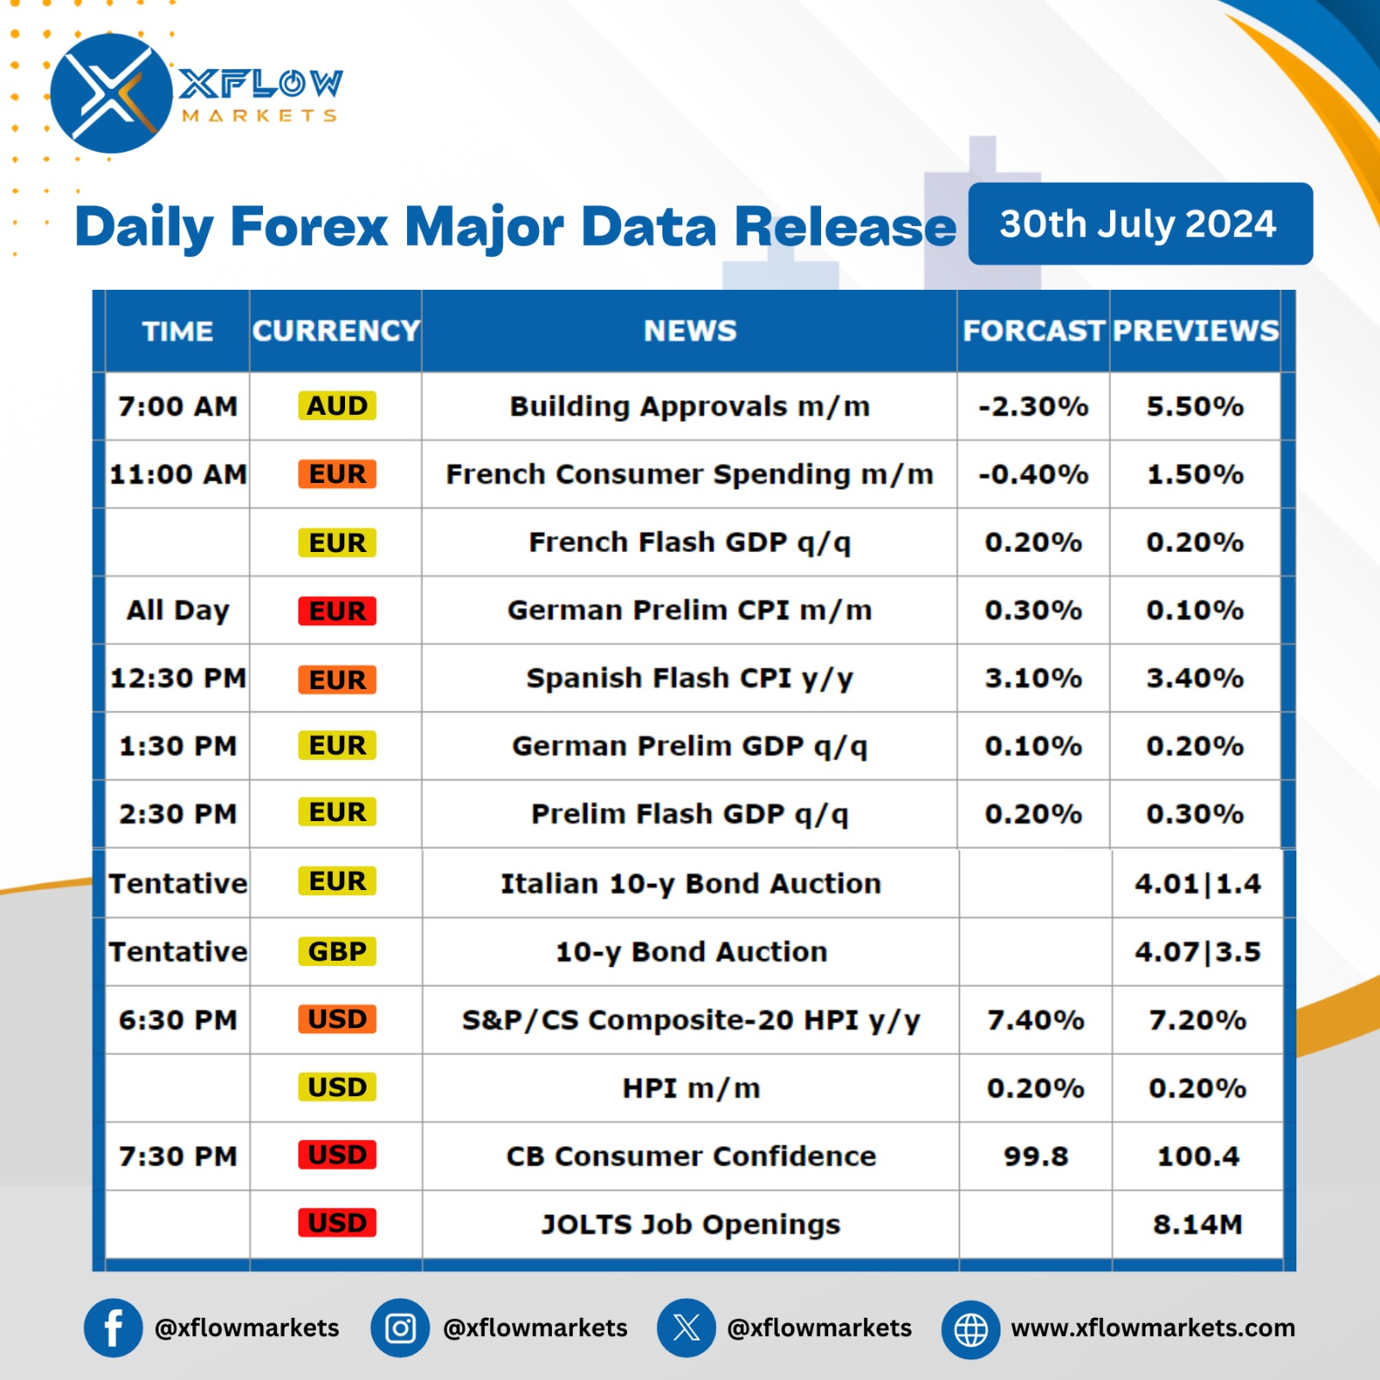

Contact us for any questions: Email:

[**support@xflowmarkets.com**](mailto:support@xflowmarkets.com)

|  |  |  |
| --- | --- | --- |
| **Follow us on FB:** | **Everyday market analysis:** | **Follow us on Twitter:** |
|  |  |  |

**Essential links:**

**Trading systems presentation - Learn and develop with us. XFlow Markets will provide you with all the help you need**

**- free seminars, webinars and learning materials.**

**Global Market Analysis - Use analysis of our professionals and be up to date.**

**DISCLAIMER:**

The content of this page has been prepared with care and diligence and with the knowledge of the author and are prepared for informative purpose only. The content of this page does not constitute investment advice. XFlow Markets does not take responsibility for investment decisions and for losses made under the influence of the information published on this website. The Client should always base his investment decisions on his own judgment. You should understand that these instruments are highly related with huge risk, and incase look for an independent advice if you have any doubts.

