**XFlow** MARKETS

PULSE

D A I L Y - R E P O R T

30-09-2024

**USD/JPY**  **CMP** – 141.75

USD/JPY is trading at 141.75, 0.28% down since previous day close. After being rejected around 143.00, the pair is currently trading at about 142.50 in Asian trading on Monday. As investors make assumptions about Japan's impending snap election, negative Japanese equities pull the pair down. Still, a mixed set of data from Japan and a surge in Chinese stocks limit the pair's losses. The pair is trading below the 50-day moving average, indicating a bearish trend, based on technical analysis. 140.33 is the nearest support.

**Resistance– 146.50-148.13 Pivot- 142.65 Support–140.33-138.81 Expected Trend- Bearish**

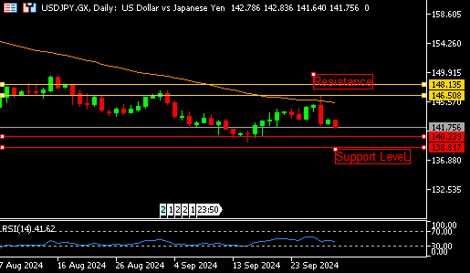

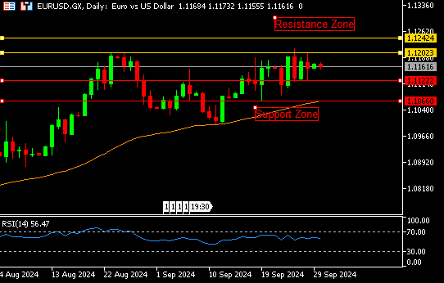

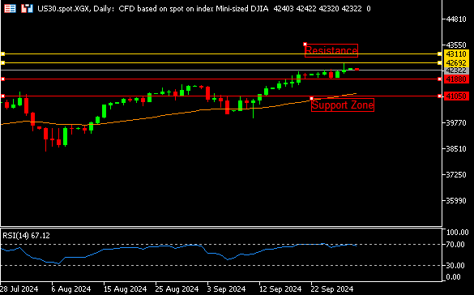

**EUR/USD**  **CMP** – 1.1161

EUR/USD is trading at 1.1161, 0.03% down since previous day close. Monday morning in early Europe, EUR/USD is bouncing about 1.1200. The two, waiting for Fed Chair Powell's speech and the flash German CPI figures. The US dollar (USD) is one of the main factors impacting on the currency pair as it crawls higher amid some repositioning action ahead of the release of the US (PCE) Price Index. An upward gap in the beginning indicates a good tendency. Support is available at 1.1122.

**Resistance-1.1202-1.1242 Pivot- 1.1167**

**Support- 1.1122-1.1066 Expected Trend-** **Bullish**

**US30**  **CMP** – 42322

US30 is trading at 42322, 0.02% down since previous day close. Before the morning bell on Monday, investors continued to pour money into the DJI, driving it to a new closing high. As a result, the index was flashing green arrows. Fresh evidence supporting the Fed's anticipated rate decreases was provided by the most recent inflation report. An overbought zone and a continuation of the rally are suggested by the daily chart analysis when the RSI touches 67. If we move upward, 42692 is the nearest barrier.

**Resistance: 42692-43110 Pivot- 42145**

**Support: 41880-41050 Expected Trend- Bullish**

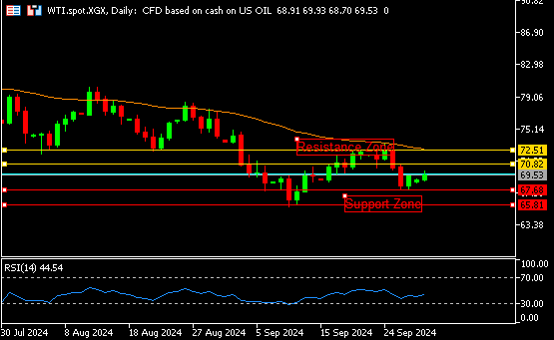

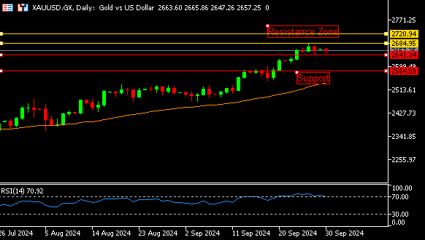

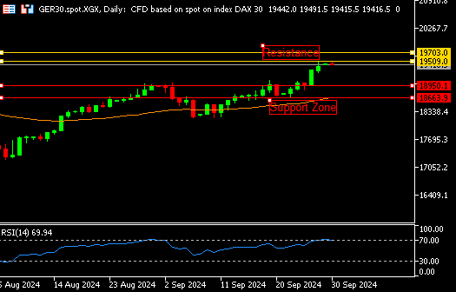

**GER30** **CMP** – 19429

GER30 is trading at 19429, 0.04% down since previous day close. On Monday, the final day of September, European stock markets fell as traders took in a number of regional economic reports and the varying results of the flagship Asian indices. As a result of profit warnings from the fourth and fifth-largest automakers in Europe, auto names have declined, and major European share indices opened marginally down on Monday. The selling is underway on the 4-hour chart. The nearest available support is 19257.

**Resistance – 19509-19703 Pivot- 19193**

**Support – 18950-18663 Expected Trend – Bearish**

**GOLD** **CMP** – 2656

XAU/USD is trading at 2656, 0.02% down since previous day close. Powell's speech is anticipated, but the gold price is still limited in a range below its all-time high. A slew of stimulus announcements from China are believed to be driving up investor demand for riskier assets, which is good news for the precious metal. The daily chart's (RSI) is still in the vicinity of the overbought zone, according to the examination of the daily chart. The trading range for the pair is consolidating. 2684 is the closest resistance.

**Resistance –2684-2720 Pivot-2662**

**Support –2641-2584 Expected Trend- Bearish**

**WTI**  **CMP** – 69.53

WTI is trading at 69.53, 0.31% up since previous day close. With supply disruption fears in the Middle East and China's recent round of stimulus measures aimed at stabilizing the country's housing market, oil prices rose 1% in early European trading. Fears of a wider Middle East conflict, following Israel's attacks against Hezbollah targets in Lebanon and Houthi targets in Yemen, are also driving up prices. In the grand scheme of things, the pair is positively traded. 70.82 is the closest resistance.

**Resistance – 70.82-72.51 Pivot – 68.07**

**Support – 67.68-65.81 Expected Trend– Bullish**

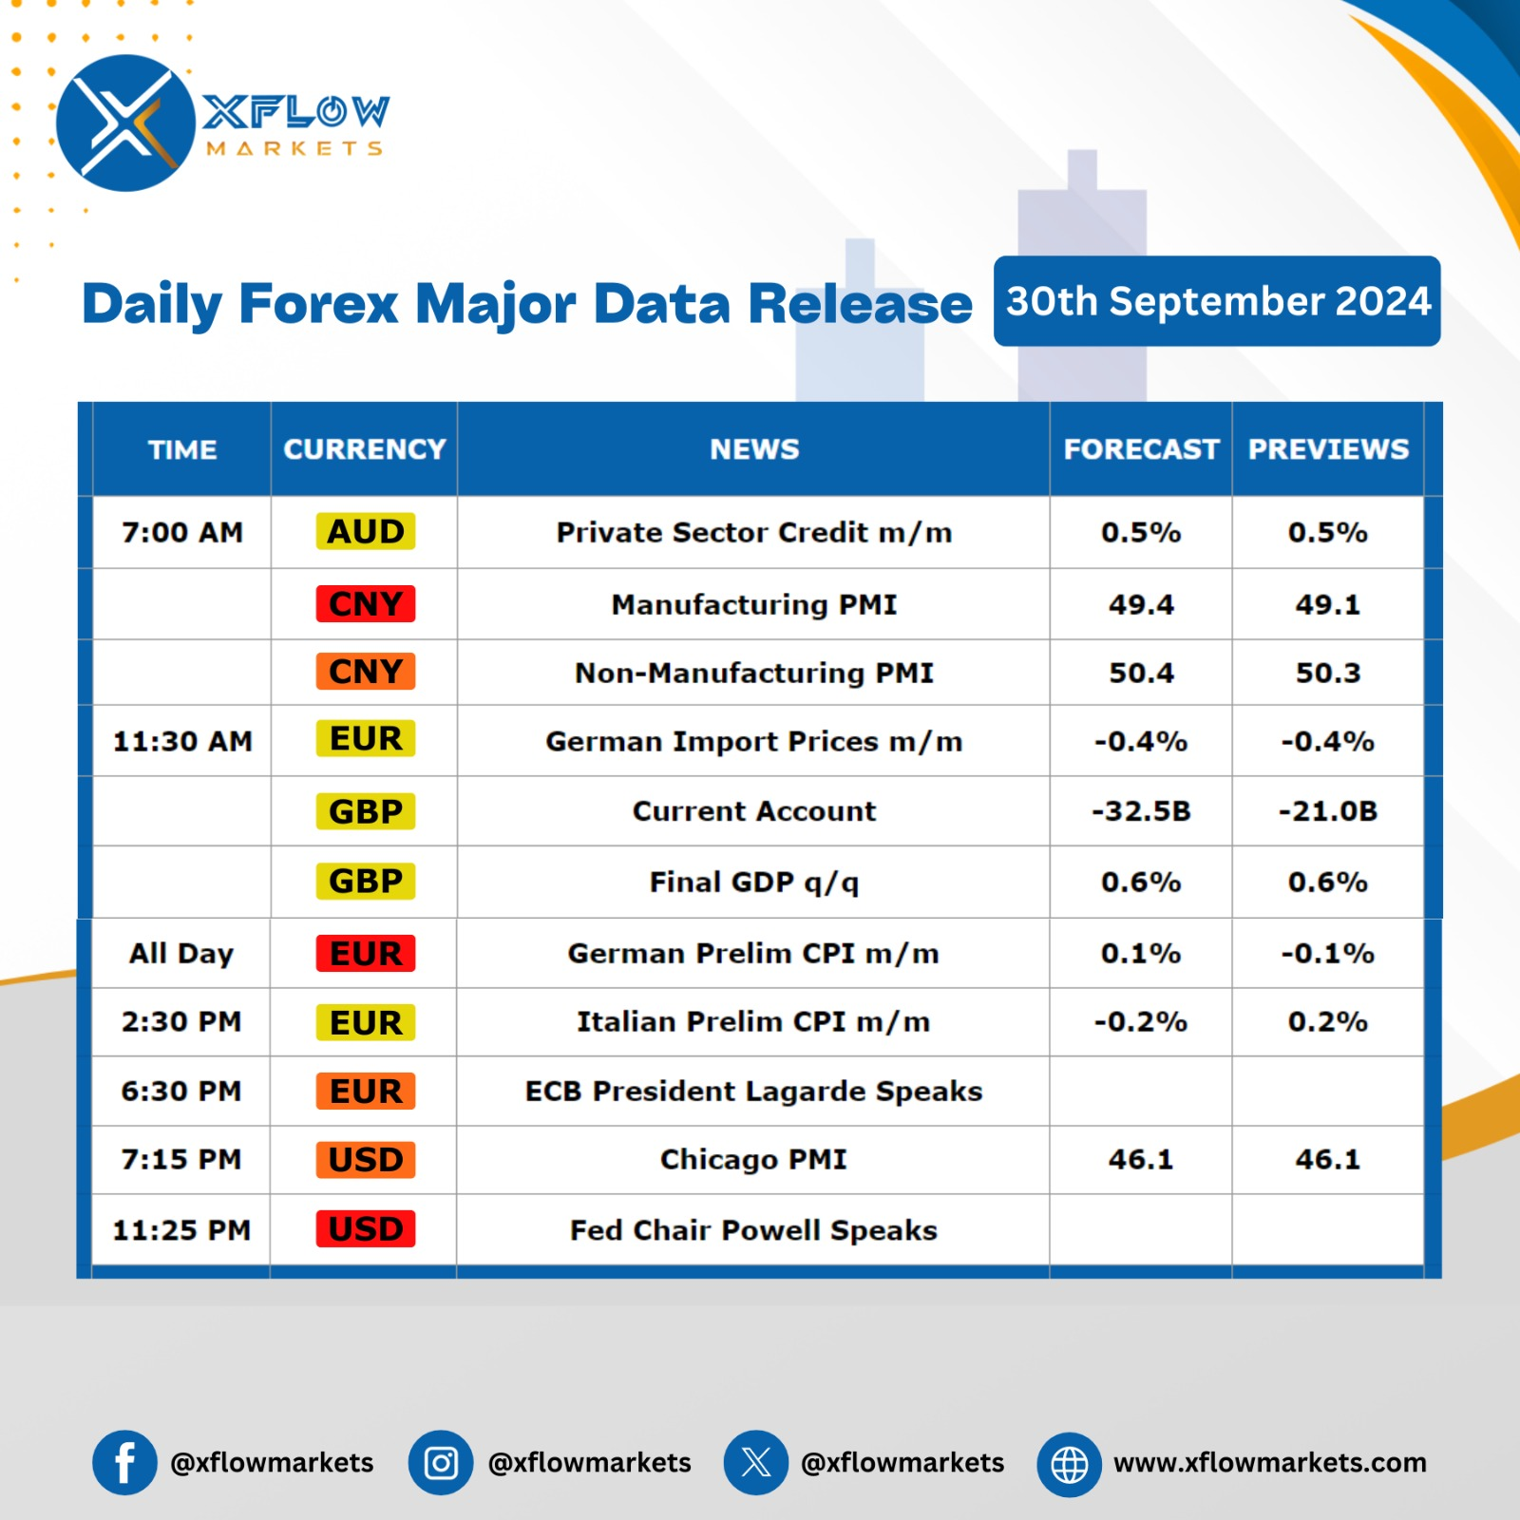

Contact us for any questions: Email:

[**support@xflowmarkets.com**](mailto:support@xflowmarkets.com)

|  |  |  |
| --- | --- | --- |
| **Follow us on FB:** | **Everyday market analysis:** | **Follow us on Twitter:** |
|  |  |  |

**Essential links:**

**Trading systems presentation - Learn and develop with us. XFlow Markets will provide you with all the help you need**

**- free seminars, webinars and learning materials.**

**Global Market Analysis - Use analysis of our professionals and be up to date.**

**DISCLAIMER:**

The content of this page has been prepared with care and diligence and with the knowledge of the author and are prepared for informative purpose only. The content of this page does not constitute investment advice. XFlow Markets does not take responsibility for investment decisions and for losses made under the influence of the information published on this website. The Client should always base his investment decisions on his own judgment. You should understand that these instruments are highly related with huge risk, and incase look for an independent advice if you have any doubts.

