**XFlow** MARKETS

PULSE

D A I L Y - R E P O R T

08-10-2024

**USD/JPY**  **CMP** – 147.86

USD/JPY is trading at 146.86, 0.19% down since previous day close. The Japanese yen is recovering further from a two-month low versus the USD reached on Monday. Geopolitical tensions strengthen the safe-haven JPY and put downward pressure on the pair. The uncertainty surrounding the BoJ rate hike curbs JPY gains and likely limit the major's additional losses. A little drop in the US dollar puts downward pressure on the pair. When viewed over a longer time frame, the pairs trade negatively. The nearest support is at 145.68

**Resistance– 149.76-154.01 Pivot- 148.39 Support–145.68-143.49 Expected Trend- Bearish**

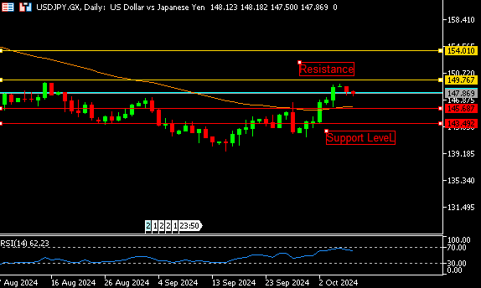

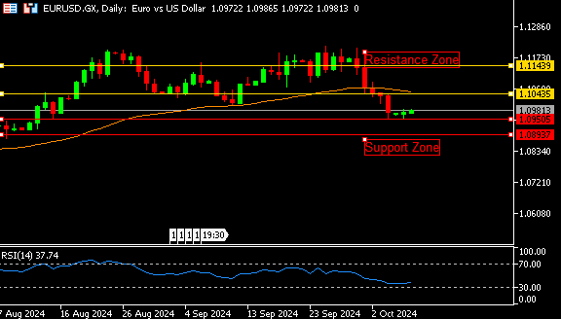

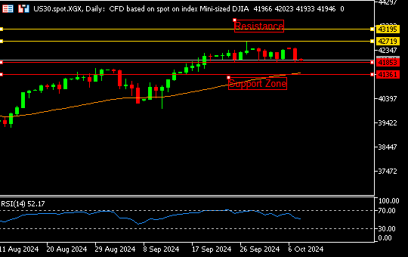

**EUR/USD**  **CMP** – 1.0981

EUR/USD is trading at 1.0981, 0.09% up since previous day close. In Tuesday's early European trading hours, the EUR/USD remains on track to break beyond 1.1000. Despite a broad drop in the US dollar and good German industrial production figures, the pair remains supported. However, the cautious mindset could limit the pair's recovery ahead of the Fed's speech. According to technical analysis, the market is in an oversold zone; at this point, buying may begin. On the upside, the nearest resistance is 1.1043,

**Resistance-1.1043-1.1143 Pivot- 1.0972**

**Support- 1.0950-1.0893 Expected Trend-** **Bullish**

**US30**  **CMP** – 41941

US30 is trading at 41941, 0.15% down since previous day close. US stocks are restrained as rate uncertainty grows, following a strong payrolls data that cast doubt on the Federal Reserve's plans to drop interest rates quickly. Wall Street indexes sank dramatically on Monday as traders priced out another massive rate decrease by the Fed, while a slew of other negative factors also weighed. A gap-up opening indicates a positive trend. On the upside, the closest resistance is 42719, while the nearest support is 41853.

**Resistance: 42719-43195 Pivot- 42228**

**Support: 41853-41361 Expected Trend- Bullish**

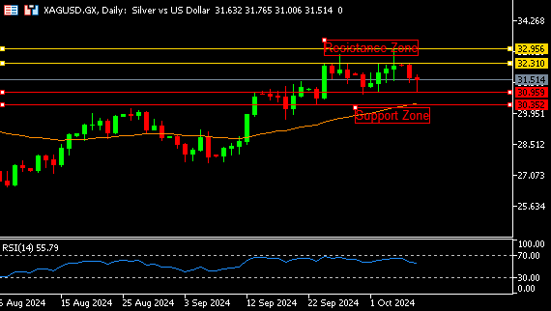

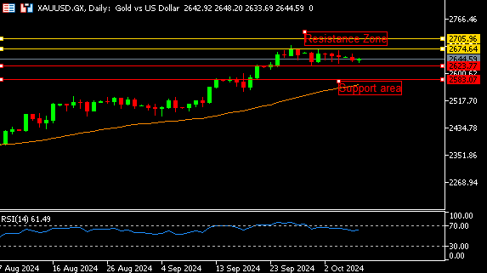

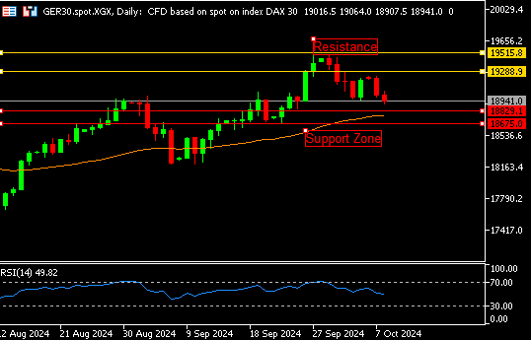

**GER30** **CMP** – 18941

GER30 is trading at 18941, 0.58% down since previous day close. On Tuesday, European equities fell to two-week lows as a dearth of new specifics about China's stimulus plans spurred a selloff in sectors related to the world's second-largest economy, such as mining and luxury. BASF, Porsche AG, and Siemens all suffered losses. Miners suffered the greatest drop among European sectors, falling 4.4%. A gap down opening on the daily chart indicates a downward trend. The nearest helpline number is 18829.

**Resistance – 19288-19515 Pivot- 19081**

**Support – 18829-18675 Expected Trend – Bearish**

**GOLD** **CMP** – 2644

XAU/USD is trading at 2644, 0.02% up since previous day close. The gold price continues to struggle to generate any serious traction, remaining stuck to a similar trading range established over the last week or two. Friday's positive US jobs report provided fresh evidence of a relatively resilient labour market, prompting investors to reduce their predictions for an enormous interest rate cut by the Federal Reserve in November. A gap-down opening indicates a decline. The nearest support is 2623.

**Resistance –2674-2705 Pivot-2647**

**Support –2623-2583 Expected Trend- Bearish**

**SILVER**  **CMP** – 31.51

XAG/USD is trading at 31.51, 0.91% down since previous day close. Silver prices fell to 31 per ounce on Tuesday, falling for the second consecutive day as the dollar strengthened and Treasury yields rose. These developments came as a stronger-than-expected US jobs report forced investors to revise their predictions for (Fed) interest rate cuts, pricing out the possibility of another 50basis point decrease in November. Today, the trend for silver is bearish. On the downside, the nearest support is 30.95; if it breaks, hit 30.59.

**Resistance – 32.31-32.95 Pivot – 31.82**

**Support – 30.95-30.35 Expected Trend– Bearish**

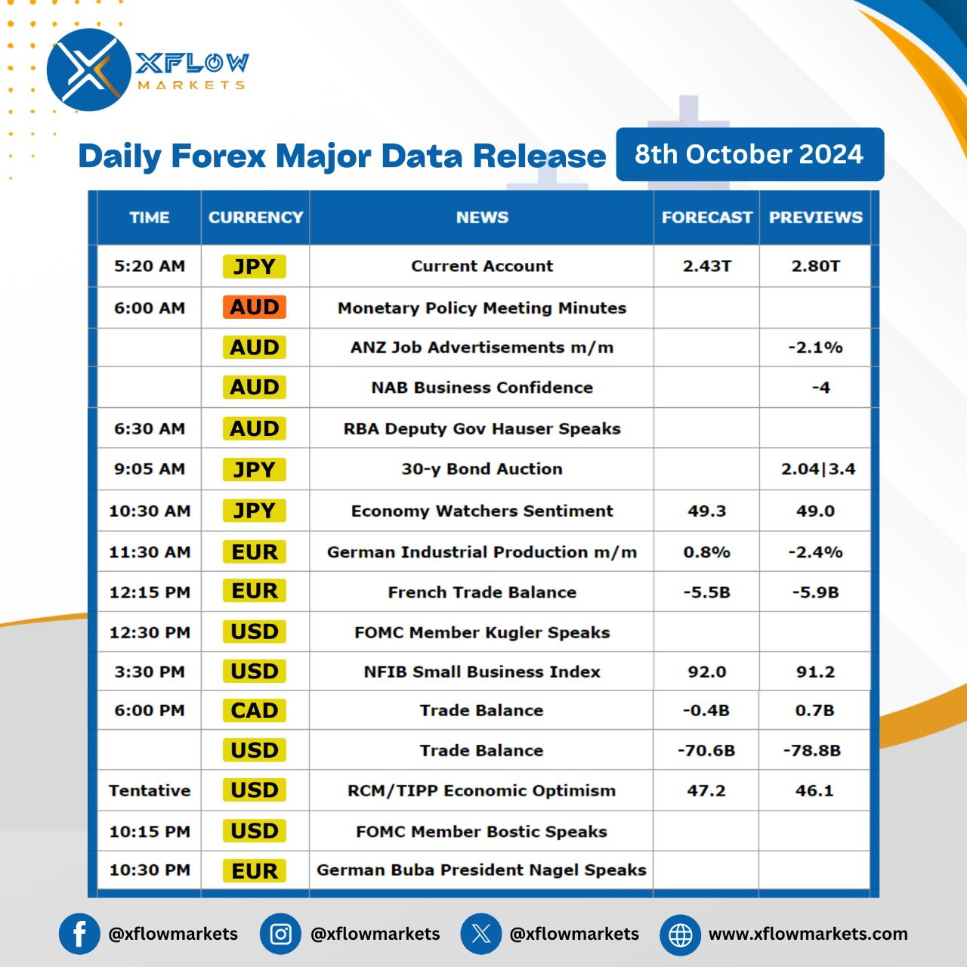

Contact us for any questions: Email:

[**support@xflowmarkets.com**](mailto:support@xflowmarkets.com)

|  |  |  |
| --- | --- | --- |
| **Follow us on FB:** | **Everyday market analysis:** | **Follow us on Twitter:** |
|  |  |  |

**Essential links:**

**Trading systems presentation - Learn and develop with us. XFlow Markets will provide you with all the help you need**

**- free seminars, webinars and learning materials.**

**Global Market Analysis - Use analysis of our professionals and be up to date.**

**DISCLAIMER:**

The content of this page has been prepared with care and diligence and with the knowledge of the author and are prepared for informative purpose only. The content of this page does not constitute investment advice. XFlow Markets does not take responsibility for investment decisions and for losses made under the influence of the information published on this website. The Client should always base his investment decisions on his own judgment. You should understand that these instruments are highly related with huge risk, and incase look for an independent advice if you have any doubts.

