**XFlow** MARKETS

PULSE

D A I L Y - R E P O R T

01-10-2024

**GBP/USD**  **CMP** – 1.3374

GBP/USD is trading at 1.3374, 0.05% down since previous day close. During Tuesday's European trading hours, the GBP/USD pair is trading weakly beneath 1.3400. Prior to the US ISM Manufacturing PMI, JOLTS Job Openings, and Fed speech, the US Dollar is supported by Fed Chair Powell's less dovish comments and cautious attitude. The previous day's candle forms a doji, which indicates a trend reversal, based on the examination of the daily chart. The closest support on the downside is 1.3304; if it breaks, go to 1.3238.

**Resistance– 1.3436-1.3530 Pivot- 1.3381 Support–1.3304-1.3150 Expected Trend- Bearish**

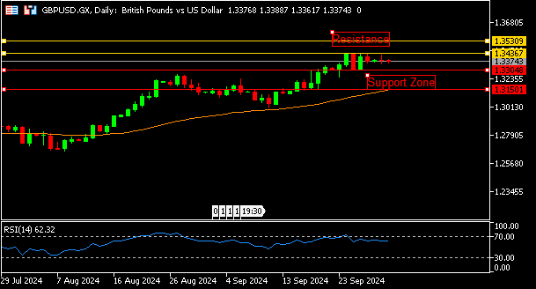

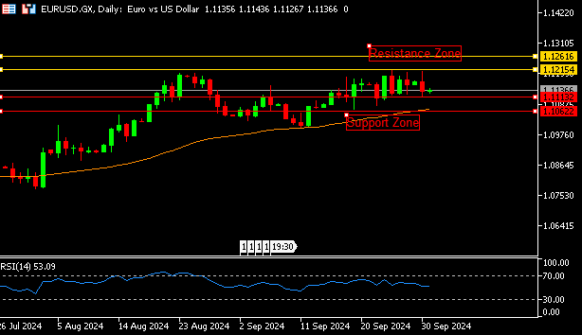

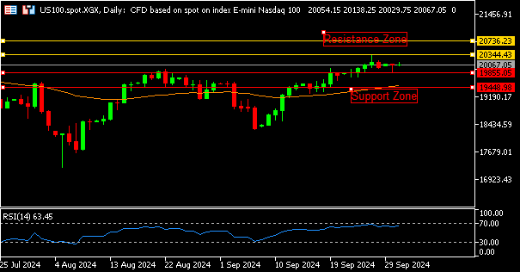

**EUR/USD**  **CMP** – 1.1136

EUR/USD is trading at 1.1136, 0.02% up since previous day close. Throughout Tuesday's European session, the EUR/USD pair manages to stay below 1.1150 and fails to make any significant progress. Tuesday's European inflation data is expected to show negative trends, which will support expectations that the European Central Bank will lower interest rates later in the month. The four-hour chart shows that the negative tendency is starting to reappear. The nearest support is 1.1113, and the first resistance level is 1.1215.

**Resistance-1.1215-1.1261 Pivot- 1.1152**

**Support- 1.1113-1.1062 Expected Trend-** **Bearish**

**US100**  **CMP** – 20067

US100 is trading at 20067, 0.24% up since previous day close. The major indexes on Wall Street were neutral as investors took a breather following a week of gains and proceeded with caution in front of multiple job reports. Following Federal Reserve Chair Jerome Powell's most recent address, strategists at Goldman Sachs repeated their forecast that the central bank would decrease interest rates by another 25 basis points in 2024. The daily chart shows that the index moves inside a range that is consolidative. 20344 is the closest resistance.

**Resistance: 20344-20736 Pivot- 20041**

**Support: 19855-19448 Expected Trend- Neutral**

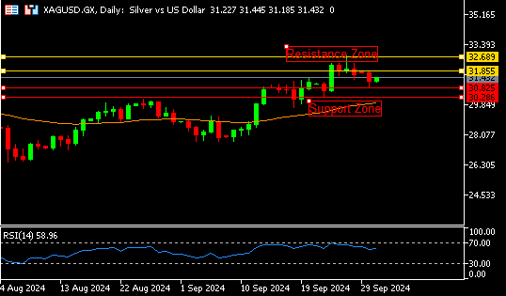

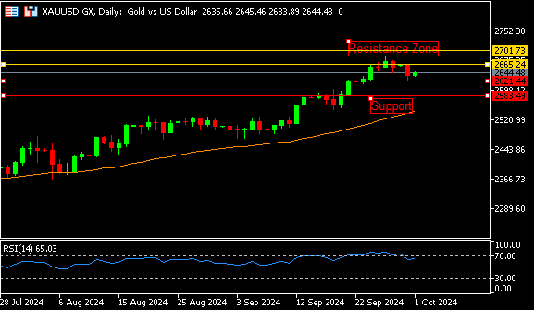

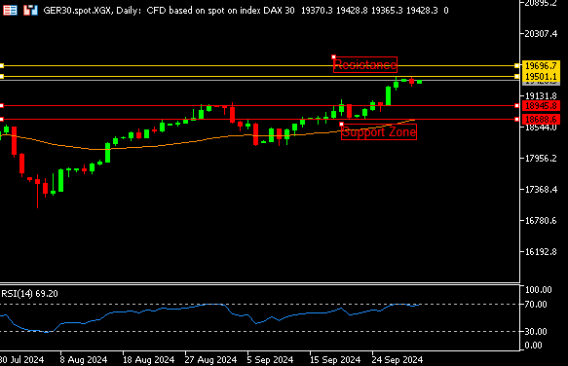

**GER30** **CMP** – 19428

GER30 is trading at 19428, 0.14% up since previous day close. As traders awaited the publication of Eurozone inflation statistics, the DAX rose 0.3% to trade around the 19380 on Tuesday, beating most of its European counterparts. The optimism around China seems to have been fleeting for luxury, considering the general anticipation of yet another subpar reporting season for the industry. A downward gap at the start indicates a bad trend. On the upside, 19231 is the closest support and 19501 is the closest resistance.

**Resistance – 19501-19696 Pivot- 19401**

**Support – 18945-18688 Expected Trend – Bearish**

**GOLD** **CMP** – 2644

XAU/USD is trading at 2644, 0.37% up since previous day close. Staying below the record peak hit last week, the price of gold maintains a slight intraday increase. Demand for the precious metal that provides a safe haven is believed to be primarily driven by the possibility of geopolitical tensions in the Middle East increasing further. The gold price is trading above the 50-day moving average (50 MA), which indicates that the uptrend may continue, according to the technical forecast. 2665 represents the nearest resistance.

**Resistance –2665-2701 Pivot-2641**

**Support –2621-2583 Expected Trend- Bullish**

**SILVER**  **CMP** – 31.43

SILVER is trading at 31.43, 0.92% up since previous day close. Silver sees some encouraging movement on Tuesday during the Asian session. The chair of the (Fed) downplayed expectations for more significant rate reduction this year, with investors looking to this week's labour statistics for additional clues. Reduced central bank demand from lessening geopolitical tensions is one factor that could limit gold's potential gains following a major price surge. For now, the trend is encouraging. 31.85 is the closest resistance.

**Resistance – 31.85-32.68 Pivot – 31.29**

**Support – 30.82-30.28 Expected Trend– Bullish**

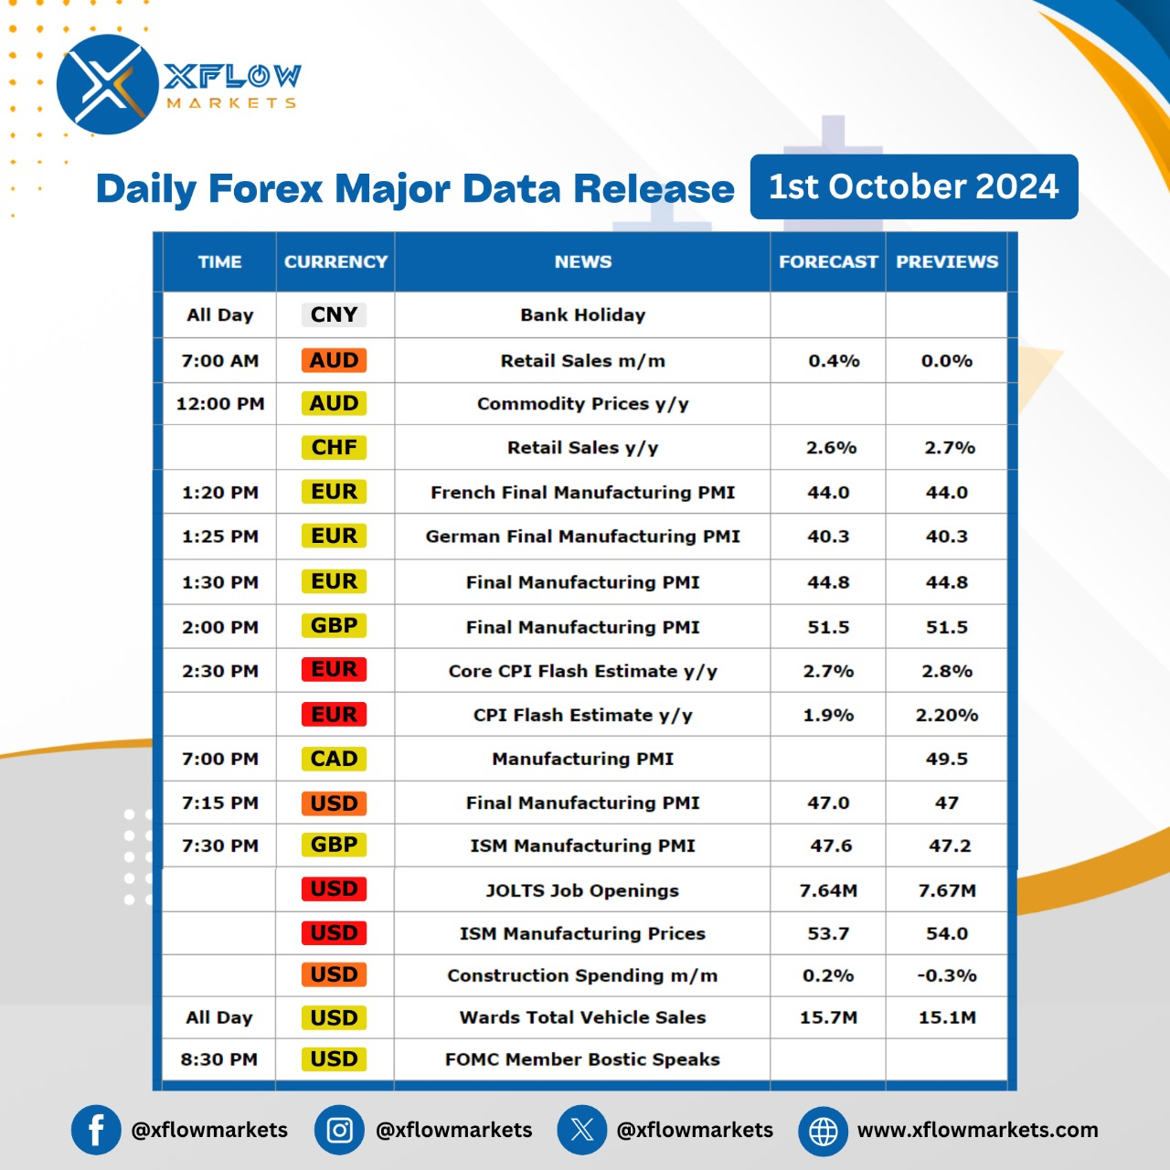

Contact us for any questions: Email:

[**support@xflowmarkets.com**](mailto:support@xflowmarkets.com)

|  |  |  |
| --- | --- | --- |
| **Follow us on FB:** | **Everyday market analysis:** | **Follow us on Twitter:** |
|  |  |  |

**Essential links:**

**Trading systems presentation - Learn and develop with us. XFlow Markets will provide you with all the help you need**

**- free seminars, webinars and learning materials.**

**Global Market Analysis - Use analysis of our professionals and be up to date.**

**DISCLAIMER:**

The content of this page has been prepared with care and diligence and with the knowledge of the author and are prepared for informative purpose only. The content of this page does not constitute investment advice. XFlow Markets does not take responsibility for investment decisions and for losses made under the influence of the information published on this website. The Client should always base his investment decisions on his own judgment. You should understand that these instruments are highly related with huge risk, and incase look for an independent advice if you have any doubts.

