**XFlow** MARKETS

PULSE

D A I L Y - R E P O R T

03-10-2024

**USD/JPY**  **CMP** – 146.41

USD/JPY is trading at 146.41, 0.11% down since previous day close. closest As PM Ishiba stated that the current situation did not call for additional interest rate increases, the value of the Japanese yen fell. Japan's Hayashi stated that the Prime Minister did not ask BoJ Governor Ueda for any details on monetary policy. A closer look at the daily chart reveals that there is a strengthening bullish bias as the pair seeks to breach above the ascending channel pattern. 147.99 is the closest resistance.

**Resistance– 147.99-149.93 Pivot- 145.47 Support–143.39-141.33 Expected Trend- Bullish**

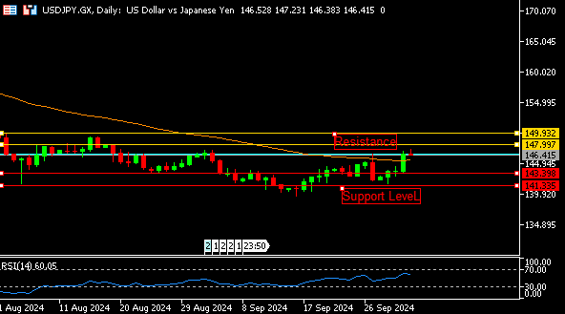

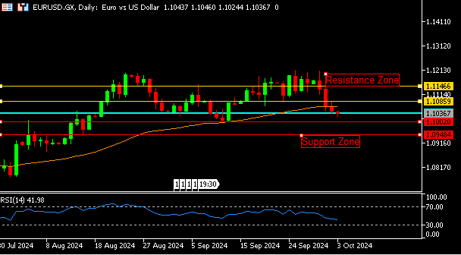

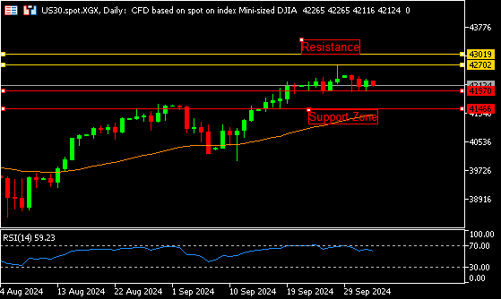

**EUR/USD**  **CMP** – 1.1036

EUR/USD is trading at 1.1036, 0.11% down since previous day close. In the European morning on Thursday, EUR/USD is falling toward 1.1000. Long-term USD strength is negative for the pair due of diminishing irrational Fed rate cut bets and Middle East escalation. The Euro is under threat from growing expectations for a 50basis point rate decrease by the ECB in October. The EUR/USD pair is trading at the lower end of Tuesday's range, indicating a bearish technical outlook. The 1.1002 support is the closest.

**Resistance-1.1085-1.1146 Pivot- 1.1054**

**Support- 1.1002-1.0948 Expected Trend-** **Bearish**

**US30**  **CMP** – 42188

US30 is trading at 42188, 0.22% down since previous day close. US stocks declined on Thursday ahead of fresh economic data. The previous session saw investors adopt a cautious approach as mood was affected by the possibility of Israel taking revenge for an attack earlier this week by Iran. Meanwhile, Levi Strauss says it is considering options for its struggling Dockers brand, and Tesla reports that its quarterly deliveries are below projections. The index is trading below zero territory. 41970 is the closest support.

**Resistance: 42702-43019 Pivot- 42141**

**Support: 41970-41466 Expected Trend- Bearish**

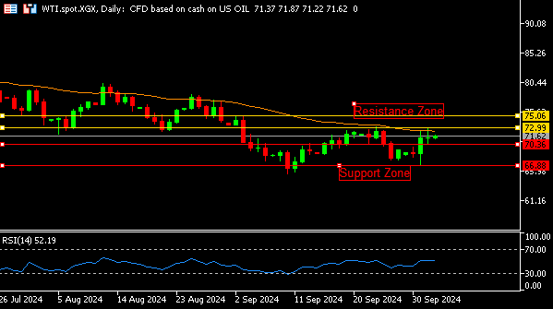

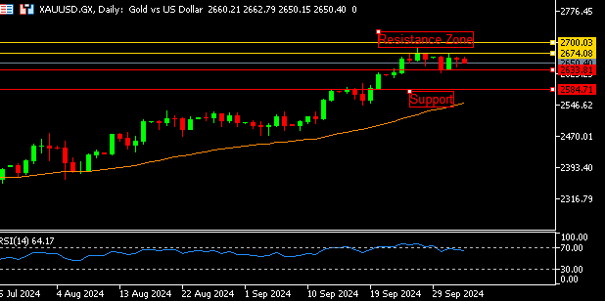

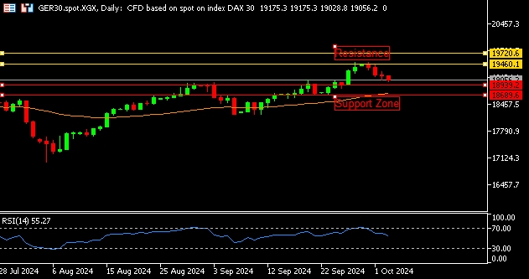

**GER30** **CMP** – 19088

GER30 is trading at 19088, 0.39% down since previous day close. While investors examined important inflation data for the European Union. European shares fell on Thursday, led by German technology company SAP. Leading sectoral falls was the automobile industry, which dropped 2.1% to its lowest level in almost a year. Stellantis, which fell more than 4% to a new low, was the largest decliner among cars. The technical view indicates a negative trend when the RSI reaches 54. 18939 is the nearest support.

**Resistance – 19460-19720 Pivot- 19268**

**Support – 18939-18689 Expected Trend – Bearish**

**GOLD** **CMP** – 2650

XAU/USD is trading at 2650, 0.14% down since previous day close. Fresh sellers are drawn to the gold price as it rose overnight from the 2,641 area. This increases the likelihood of a full-fledged conflict in the area and reduces investor desire for riskier assets, as seen by the generally downbeat tone around the equities markets and supports the price of gold, a safe haven. A doji candle from the previous day forms, indicating a potential trend reversal. The nearest support on the downside is 2633.

**Resistance –2674-2700 Pivot-2654**

**Support –2633-2584 Expected Trend- Bearish**

**WTI**  **CMP** – 71.62

WTI is trading at 71.62, 0.27% up since previous day close. The US benchmark for crude oil, West Texas Intermediate, is now trading at about 70.60 on Thursday. WTI continues to rise as traders evaluate Middle Eastern oil supply risks following Iran's missile attack on Israel earlier this week. Iran has pledged to retaliate, raising concerns about potential interruptions to Iranian oil production facilities. The daily chart analysis shows that there is positive trading between the pairs. 72.99 is the closest resistance.

**Resistance – 72.99-75.06 Pivot – 70.83**

**Support – 70.36-66.88 Expected Trend– Bullish**

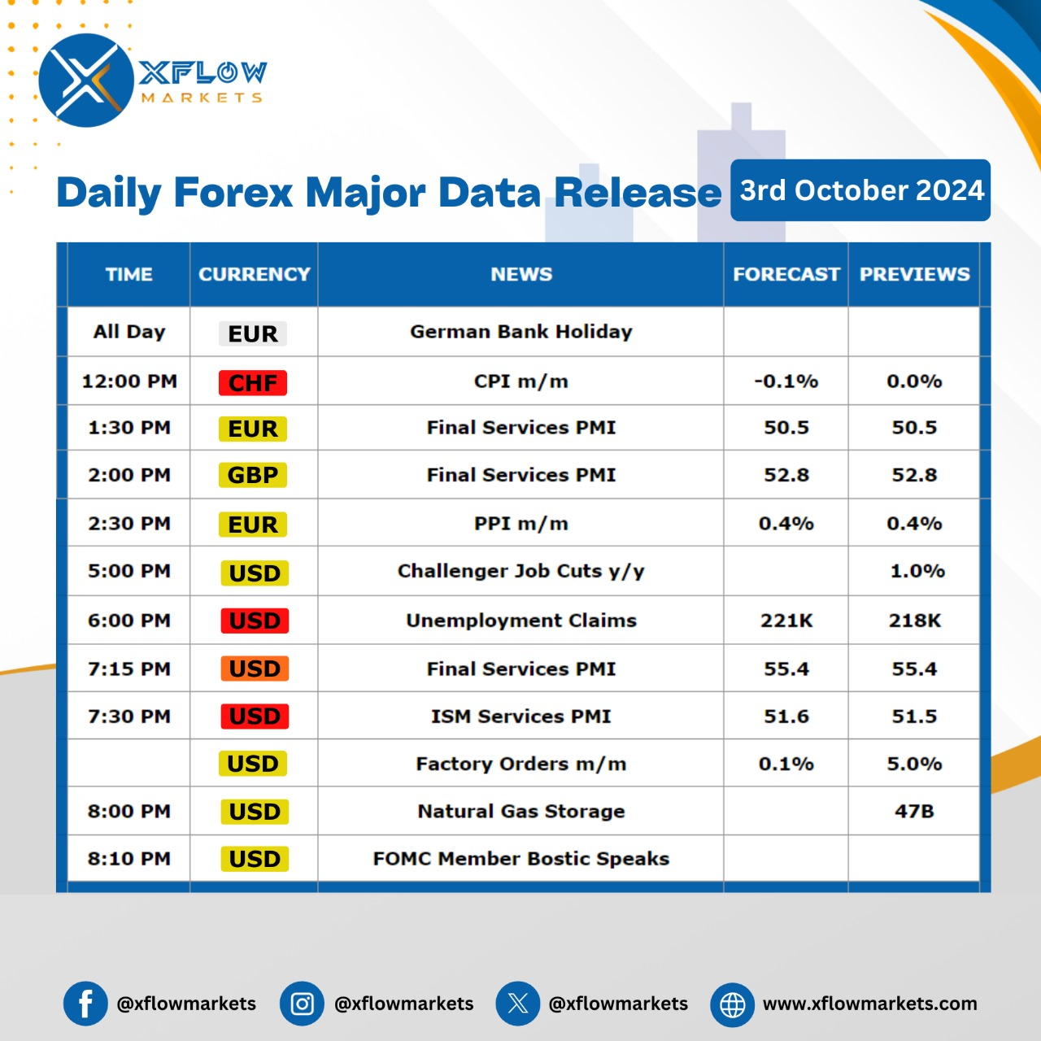

Contact us for any questions: Email:

[**support@xflowmarkets.com**](mailto:support@xflowmarkets.com)

|  |  |  |
| --- | --- | --- |
| **Follow us on FB:** | **Everyday market analysis:** | **Follow us on Twitter:** |
|  |  |  |

**Essential links:**

**Trading systems presentation - Learn and develop with us. XFlow Markets will provide you with all the help you need**

**- free seminars, webinars and learning materials.**

**Global Market Analysis - Use analysis of our professionals and be up to date.**

**DISCLAIMER:**

The content of this page has been prepared with care and diligence and with the knowledge of the author and are prepared for informative purpose only. The content of this page does not constitute investment advice. XFlow Markets does not take responsibility for investment decisions and for losses made under the influence of the information published on this website. The Client should always base his investment decisions on his own judgment. You should understand that these instruments are highly related with huge risk, and incase look for an independent advice if you have any doubts.

