**XFlow** MARKETS

PULSE

D A I L Y - R E P O R T

04-10-2024

**GBP/USD**  **CMP** – 1.3141

GBP/USD is trading at 1.3141, 0.21% up since previous day close. The pair rises to about 1.3150. However, the additional gain now looks illusive as traders wait for the eagerly awaited US NFP report to provide new clues regarding the Fed's interest rate stance. Although the pair may struggle to stage a significant retreat, the short-term technical picture indicates that conditions are oversold. Positive trade is occurring between the pairs. 1.3088 is the closest support on the downside and 1.3088 is the closest resistance.

**Resistance– 1.3269-1.3393 Pivot- 1.3164 Support–1.3088-1.2999 Expected Trend- Bearish**

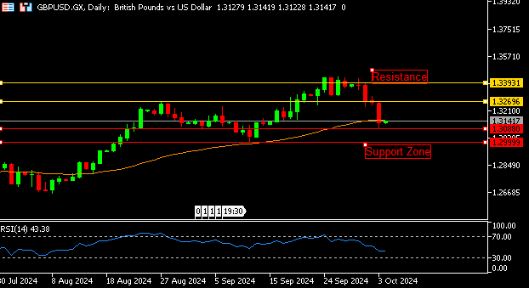

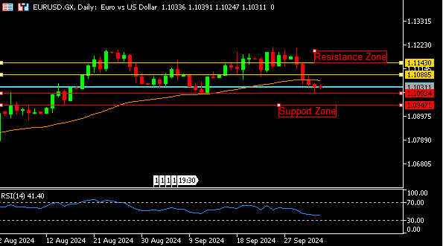

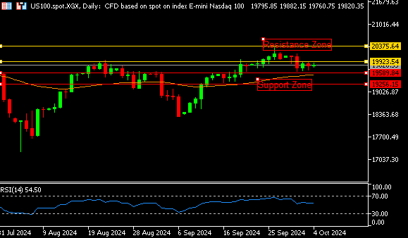

**EUR/USD**  **CMP** – 1.1031

EUR/USD is trading at 1.1031, 0.02% down since previous day close. In the European morning on Friday, the pairs Remains defensive below 1.1050. As traders avoid making new wagers ahead of the important US NFP data, the pair lacks a clear directional momentum. ECB-speak is still the major focus. More rate cuts could occur as early as this month, according to recent data on Eurozone inflation. A gap down opening indicates a bearish trend, based on daily chart analysis. When looking down, 1.1003 is the nearest support.

**Resistance-1.1088-1.1143 Pivot- 1.1029**

**Support- 1.1003-1.0947 Expected Trend-** **Bearish**

**US100**  **CMP** – 19821

US100 is trading at 19821, 0.24% up since previous day close. Over the past few weeks, Barclays strategists have grown more optimistic about the possibility of a U.S. soft landing, mostly because of China's unanticipated stimulus measures and the Federal Reserve's recent 50 basis point rate decrease. Today's NFP report is anticipated to be very important. the daily chart shows that the pairs traded above the 50-day moving average, indicating that the uptrend is likely to continue. 19923 is the closest resistance.

**Resistance: 19923-20375 Pivot- 19770**

**Support: 19589-19256 Expected Trend- Bullish**

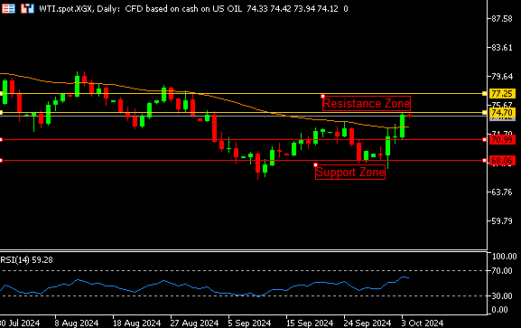

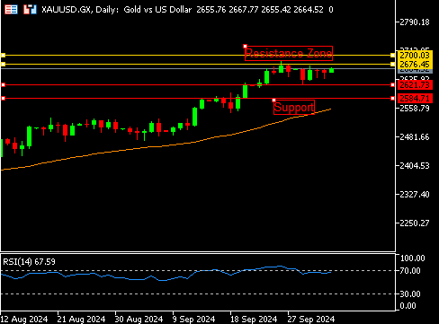

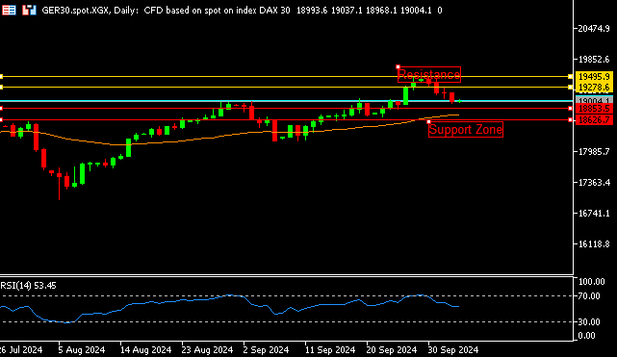

**GER30** **CMP** – 19013

GER30 is trading at 19013, 0.06% up since previous day close. With traders awaiting the much-anticipated US employment report and Middle East tensions continuing to weigh, the DAX was little changed on Friday and mirroring the overall cautious tone among its European rivals. The STOXX 600 throughout Europe increased by 0.2%. Many ECB officials are expected to give speeches, which investors will be watching. Technically speaking, the RSI touches 42, indicating a neutral trend. The nearest help number is 18853.

**Resistance – 19278-19495 Pivot- 19158**

**Support – 18853-18626 Expected Trend – Bullish**

**GOLD** **CMP** – 2664

XAU/USD is trading at 2664, 0.32% up since previous day close. For the third day in a row, the gold price is continuing its consolidation period below the crucial 2,670 static barrier. The highly consequential US is anticipated by gold traders (NFP). Fears grew as US President Biden on Thursday avoided outright denouncing Israel's possible attack on Iran, and markets are now intently following events in the Middle East. Gold is expected to trade positively and is now in a good state. the closest resistance is 2676

**Resistance –2676-2700 Pivot-2653**

**Support –2621-2584 Expected Trend- Bullish**

**WTI**  **CMP** – 74.29

WTI is trading at 74.29, 0.04% down since previous day close. The price of oil is rising for the fourth day in a row, with Friday's Asian session seeing a price per barrel of almost 73.50. Growing tensions in the Middle East were causing markets to remain on edge, and oil prices were on track for their biggest weekly increase in almost a year. A major focus for investors was the U.S. nonfarm payrolls report. When the RSI hits 61, a bullish trend is indicated. 74.70 is the closest resistance.

**Resistance – 74.70-77.25 Pivot – 72.54**

**Support – 70.99-68.06 Expected Trend– Bullish**

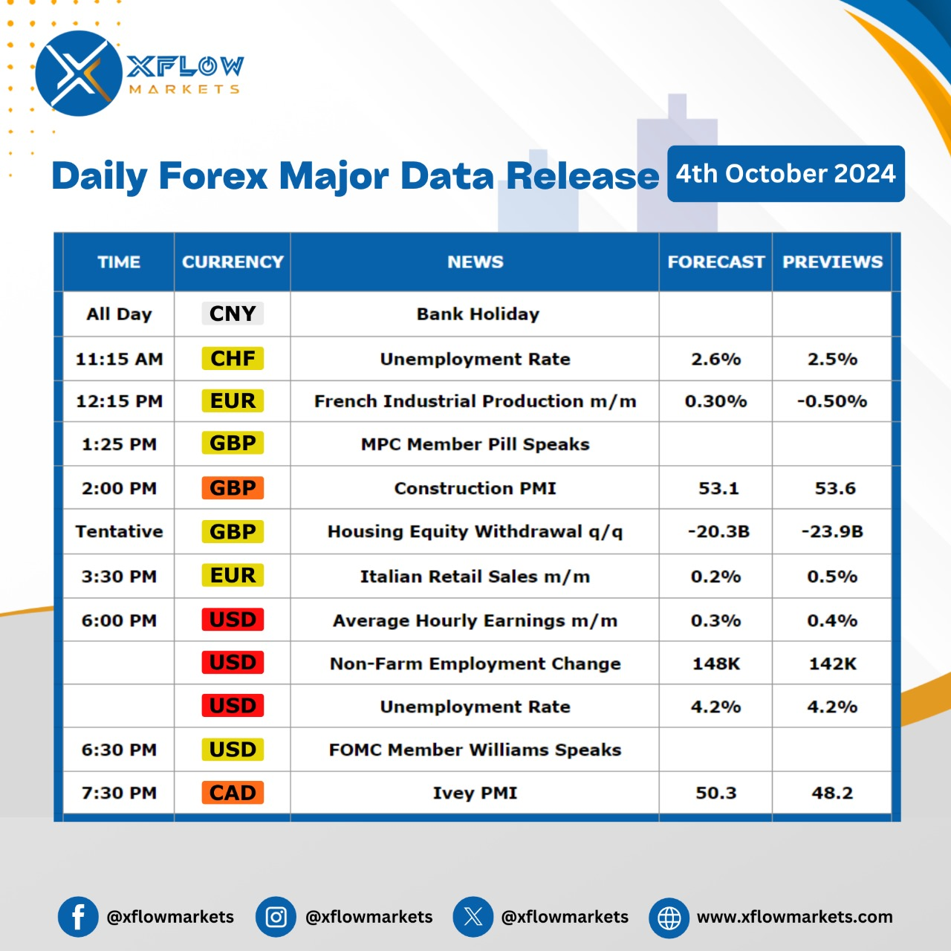

Contact us for any questions: Email:

[**support@xflowmarkets.com**](mailto:support@xflowmarkets.com)

|  |  |  |
| --- | --- | --- |
| **Follow us on FB:** | **Everyday market analysis:** | **Follow us on Twitter:** |
|  |  |  |

**Essential links:**

**Trading systems presentation - Learn and develop with us. XFlow Markets will provide you with all the help you need**

**- free seminars, webinars and learning materials.**

**Global Market Analysis - Use analysis of our professionals and be up to date.**

**DISCLAIMER:**

The content of this page has been prepared with care and diligence and with the knowledge of the author and are prepared for informative purpose only. The content of this page does not constitute investment advice. XFlow Markets does not take responsibility for investment decisions and for losses made under the influence of the information published on this website. The Client should always base his investment decisions on his own judgment. You should understand that these instruments are highly related with huge risk, and incase look for an independent advice if you have any doubts.

