**XFlow** MARKETS

PULSE

D A I L Y - R E P O R T

07-10-2024

**GBP/USD**  **CMP** – 1.3110

GBP/USD is trading at 1.3110, 0.02% down since previous day close. In European trading on Monday, GBP/USD holds 1.3100, wiping off early gains. Following Friday's spectacular Nonfarm Payrolls report, the USD finds new life, shrugging off risk flows as focus shifts to speeches from multiple Fed members for more support. As the market's attention turns to the US labour market statistics, the pair's technical picture shows that the negative bias is still present. The closest support is 1.3066, while the closest resistance is 1.3178.

**Resistance– 1.3178-1.3305 Pivot- 1.3118 Support–1.3066-1.2970 Expected Trend- Bearish**

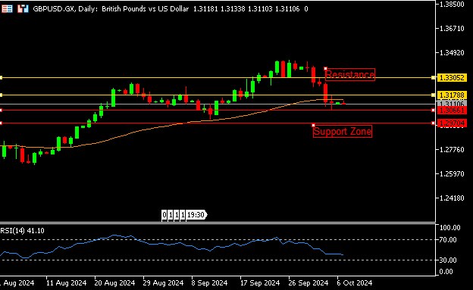

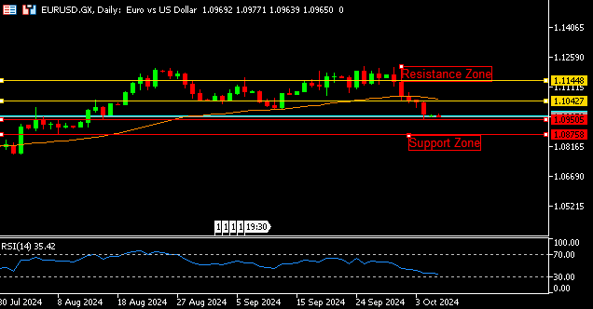

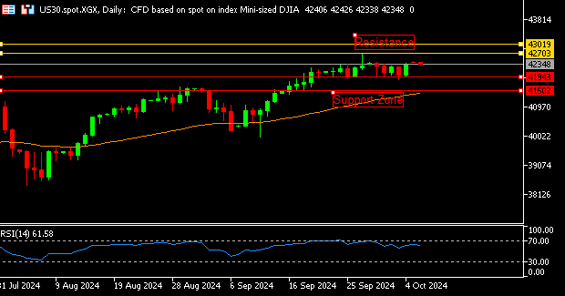

**EUR/USD**  **CMP** – 1.0966

EUR/USD is trading at 1.0966, 0.05% down since previous day close. Monday's early European session saw the EUR/USD exchange rate surpassing 1.0950. Despite the risk-on sentiment in the market, the pair struggles as the US Dollar holds onto its robust gains driven by US NFP. We're still focused on Fed speak and Eurozone statistics. Indicating that the pair has further room to fall before technically becoming oversold, the 4-hour chart's (RSI) indicator remains above 30. On the down side, 1.0950 is the nearest support.

**Resistance-1.1042-1.1144 Pivot- 1.0969**

**Support- 1.0950-1.0875 Expected Trend-** **Bearish**

**US30**  **CMP** – 42348

US30 is trading at 42348, 0.04% down since previous day close. With attention shifting to corporate earnings in the coming days, the U.S. stock index increased somewhat as optimism persisted following solid payrolls data from the previous week. Wall Street had a big increase on Friday as worries about a weakening US economy were allayed by better-than-expected NFP statistics. Daily chart analysis indicates that an opening gap up indicates an uptrend. The closest resistance on the upside is 42703.

**Resistance: 42703-43019 Pivot- 41995**

**Support: 41943-41502 Expected Trend- Bullish**

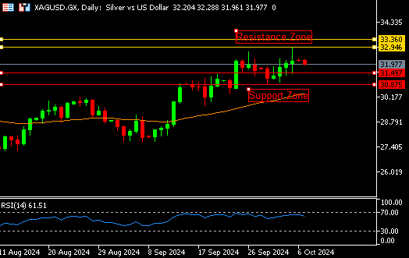

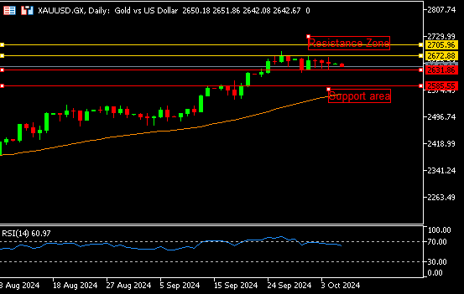

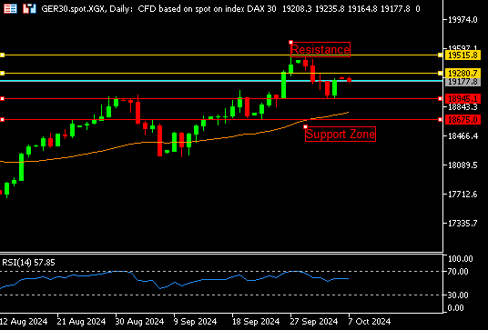

**GER30** **CMP** – 19177

GER30 is trading at 19177, 0.13% down since previous day close. As traders wait for more catalysts as the excitement surrounding the positive US jobs report wanes, the DAX fell 0.4% to trade near the 19050 mark on Monday. This was in line with the overall cautious attitude among its European rivals. The Middle East scenario is still quite important at the same time. Corporately speaking, the largest losers were Rheinmetall, Bayer, Continental, and Munich Re. 19280 is the closest resistance.

**Resistance – 19280-19515 Pivot- 19030**

**Support – 18945-18675 Expected Trend – Bearish**

**GOLD** **CMP** – 2641

XAU/USD is trading at 2641, 0.46% down since previous day close. Monday sees a decline in the price of gold, but it remains within a well-known range at roughly 2,650. The gold market is now focusing on statements made by US Federal Reserve members on Monday, amid the ongoing geopolitical tensions in the Middle East, in anticipation of the crucial US CPI data later this week. The gap down opening on the daily chart indicates a downward trend. 2631 is the closest support number.

**Resistance –2672-2705 Pivot-2650**

**Support –2631-2585 Expected Trend- Bearish**

**SILVER**  **CMP** – 31.89

XAG/USD is trading at 31.89, 0.90% down since previous day close. As a result of increased demand for protection and positive predictions on silver's industrial application as a result of China's stimulus, silver prices surged beyond 32.1 per ounce in October, reaching their highest level in 12 years. After Israel promised to retaliate against Iran's ballistic missile launch, concerns about more aggressive warfare in the Middle East pushed the use of safer assets. Silver is exchanged negatively. The closest assistance is 31.49

**Resistance – 32.94-33.36 Pivot – 32.24**

**Support – 31.49-30.87 Expected Trend– Bearish**

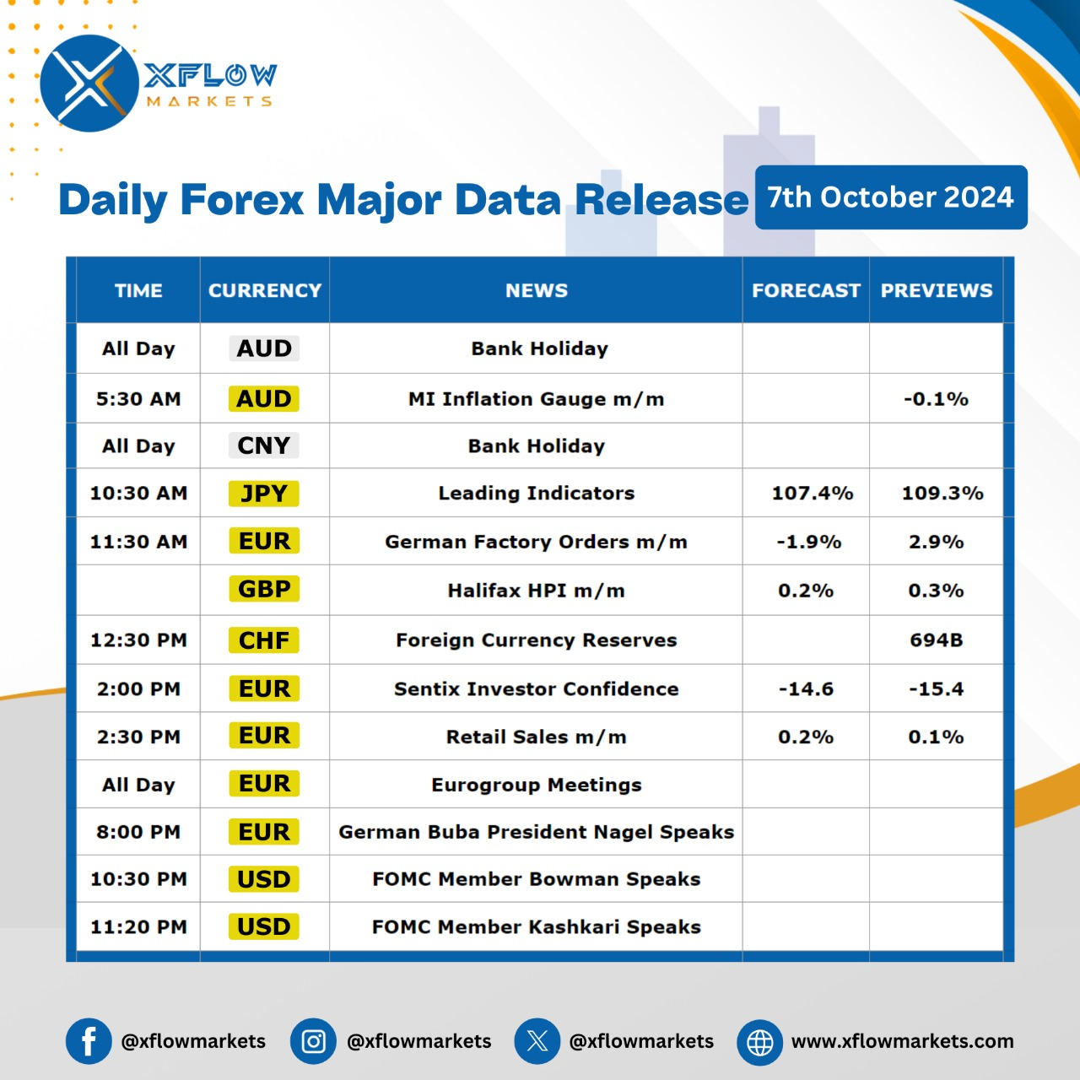

Contact us for any questions: Email:

[**support@xflowmarkets.com**](mailto:support@xflowmarkets.com)

|  |  |  |
| --- | --- | --- |
| **Follow us on FB:** | **Everyday market analysis:** | **Follow us on Twitter:** |
|  |  |  |

**Essential links:**

**Trading systems presentation - Learn and develop with us. XFlow Markets will provide you with all the help you need**

**- free seminars, webinars and learning materials.**

**Global Market Analysis - Use analysis of our professionals and be up to date.**

**DISCLAIMER:**

The content of this page has been prepared with care and diligence and with the knowledge of the author and are prepared for informative purpose only. The content of this page does not constitute investment advice. XFlow Markets does not take responsibility for investment decisions and for losses made under the influence of the information published on this website. The Client should always base his investment decisions on his own judgment. You should understand that these instruments are highly related with huge risk, and incase look for an independent advice if you have any doubts.

